

***COME GROW WITH US TO TRANSFORM HEALTHCARE COAST TO COAST***



Chief of Strategy and Development, Managed Care Executive

Prospect Medical Systems

Orange, California

POSITION SPECIFICATION

**Disclaimer: Job descriptions are not intended, nor should they be construed to be, exhaustive lists of all responsibilities, skills, efforts or working conditions associated with the job. They are intended to be accurate reflections of the principal duties and responsibilities of this position. These responsibilities and competencies listed below may change from time to time.**

**WHO WE ARE:**

**Prospect’s Mission Statement**: “We are hospitals and affiliated medical groups, working closely together for the benefit of every person who comes to us for care. We build comprehensive networks of quality healthcare services that are designed to offer our patients highly coordinated, personalized care and help them live healthier lives. Through collaboration, we strive to provide all of our patients and medical group members with the quality, affordable healthcare they need and deserve.”

Prospect Medical is a family of mission-focused healthcare professionals offering hospital and community-based health services. In partnership with their physicians, their hospitals and affiliated medical groups are committed to high-quality healthcare services tailored to the unique needs of the communities they serve.

Above all, Prospect is committed to quality in all aspects of healthcare delivery, including:

* Striving for the best patient outcomes
* Maintaining the highest standards of patient safety
* Acting with integrity at all times
* Promoting open communication
* Collaborating to better service the healthcare needs of their community



**SERVICE AREAS**

We maintain significant market

Positions throughout **Southern California,   
South Central Texas, Rhode Island, Connecticut New Jersey** and **Pennsylvania.**

**MEMBERS**

We arrange for the provision of care to over 365,000 members in our networks of over 11,000 doctors and specialists.

**HOSPITALS**

We own 20 acute care

and behavioral hospitals

in our service areas.

**MEDICAL GROUPS**

We arrange for the provision of services to our members via our quality HMO plans.

**And growing …**

**6** STATES **20** HOSPITALS

**Our Model of Coordinated Regional Care - The Next Generation Healthcare System**

Prospect has been growing its business geographically primarily by acquiring health systems and now has 20 hospitals and several inpatient facilities in 6 geographic markets in **Southern California** (Los Angeles, Orange County and the Inland Empire), **Texas, Rhode Island, Connecticut,** **Pennsylvania** and **New Jersey**. Our growth model is well poised to expand into other geographic markets. As a matter of strategy, Prospect has aligned the acquired hospitals with its employed and affiliated physicians through the development of IPAs in each existing and new market. Now there are developed IPAs in every major market—and IPAs will be developed as a lead component of its Coordinated Regional Care strategy in entering any new markets through hospital acquisition.

All of these activities are designed to move the company farther and faster toward the integrated coordinated regional care system designed to assume and manage both professional and institutional risk from payers. Prospect believes that this is the surest way to secure its place in the post-reform healthcare system.



4 to 5

24

435,000+

11,000+

**LEADERSHIP TRAITS**

PMH has a core set of values and behaviors which apply to all employees, including leaders. The PMH Leadership Traits are specific characteristics of successful leaders within Prospect.

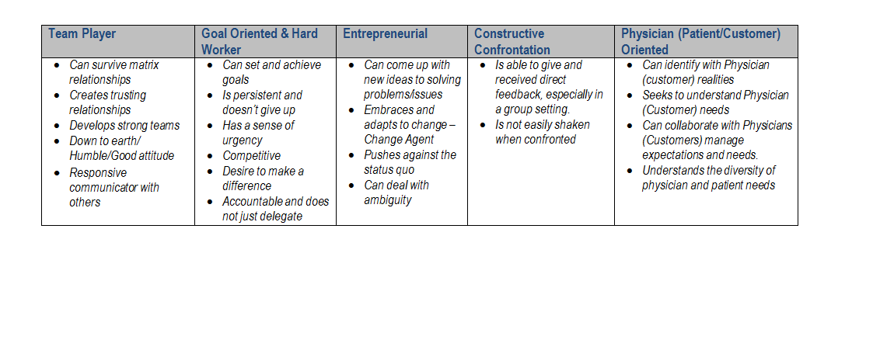

**Chief of Strategy and Development, Managed Care Executive**

**Prospect Medical Systems**

**Orange, California**

The Chief of Strategy and Development, Managed Care Executive will work closely with Prospect Medical’s IPA and Coordinated Regional Care (CRC) leadership to develop and execute organization wide initiatives that strengthen Prospect Medical System’s position in the market place. These initiatives include including growing Prospect’s member network, engaging health plans, increasing physician retention, seeking IPA and physician practice acquisition targets, and partnering with Prospect’s affiliated hospitals across the West.

This role will drive development for the IPA segment and assist in optimizing revenue for the organization. Additionally, this role will work with Prospect Medical Holding’s leadership to grow the CRC model.

**Experience and Qualifications:**

* A seasoned managed care executive (M.D. preferred) with experience creating and developing an IPA, MSO, or ACO within the State of California strongly preferred.
* A leader comfortable driving national efforts to strengthen Prospect’s integrated service delivery model through the growth of its affiliated IPA’s, MSO, and ACO.
* An operator who is not afraid to roll up his or her sleeves to do what is necessary to drive progress.
* A strategic executive with proven experience growing member networks and retaining physicians.
* A developer with a strong for-profit mentality.
* A natural competitor who lives to drive change and increase revenue.
* 10+ Years of Healthcare Experience at the executive level in a regional or national level (VP, C-Suite) strongly preferred.
* Acute care and health plan experience preferred but not required.

The successful candidate will possess an extraordinary amount of emotional and professional maturity, a thick skin, resilience, and vision.

**Education**

• Bachelor's Degree required, Master’s Degree or MBA, MD Preferred