

***COME GROW WITH US TO TRANSFORM HEALTHCARE COAST TO COAST***



Chief Medical Officer

Prospect Medical Systems

Home Base: Orange, California

Scope: California

POSITION SPECIFICATION

**Disclaimer: Job descriptions are not intended, nor should they be construed to be, exhaustive lists of all responsibilities, skills, efforts or working conditions associated with the job. They are intended to be accurate reflections of the principal duties and responsibilities of this position. These responsibilities and competencies listed below may change from time to time.**

**WHO WE ARE:**

**Prospect’s Mission Statement**: “We are hospitals and affiliated medical groups, working closely together for the benefit of every person who comes to us for care. We build comprehensive networks of quality healthcare services that are designed to offer our patients highly coordinated, personalized care and help them live healthier lives. Through collaboration, we strive to provide all of our patients and medical group members with the quality, affordable healthcare they need and deserve.”

Prospect Medical is a family of mission-focused healthcare professionals offering hospital and community-based health services. In partnership with their physicians, their hospitals and affiliated medical groups are committed to high-quality healthcare services tailored to the unique needs of the communities they serve.

Above all, Prospect is committed to quality in all aspects of healthcare delivery, including:

* Striving for the best patient outcomes
* Maintaining the highest standards of patient safety
* Acting with integrity at all times
* Promoting open communication
* Collaborating to better service the healthcare needs of their community



**SERVICE AREAS**

We maintain significant market

Positions throughout **Southern California,   
South Central Texas, Rhode Island, Connecticut New Jersey** and **Pennsylvania.**

**MEMBERS**

We arrange for the provision of care to over 365,000 members in our networks of over 11,000 doctors and specialists.

**HOSPITALS**

We own 20 acute care

and behavioral hospitals

in our service areas.

**MEDICAL GROUPS**

We arrange for the provision of services to our members via our quality HMO plans.

**And growing …**

**6** STATES **20** HOSPITALS

**Our Model of Coordinated Regional Care - The Next Generation Healthcare System**

Prospect has been growing its business geographically primarily by acquiring health systems and now has 20 hospitals and several inpatient facilities in 6 geographic markets in **Southern California** (Los Angeles, Orange County and the Inland Empire), **Texas, Rhode Island, Connecticut,** **Pennsylvania** and **New Jersey**. Our growth model is well poised to expand into other geographic markets. As a matter of strategy, Prospect has aligned the acquired hospitals with its employed and affiliated physicians through the development of IPAs in each existing and new market. Now there are developed IPAs in every major market—and IPAs will be developed as a lead component of its Coordinated Regional Care strategy in entering any new markets through hospital acquisition.

All of these activities are designed to move the company farther and faster toward the integrated coordinated regional care system designed to assume and manage both professional and institutional risk from payers. Prospect believes that this is the surest way to secure its place in the post-reform healthcare system.

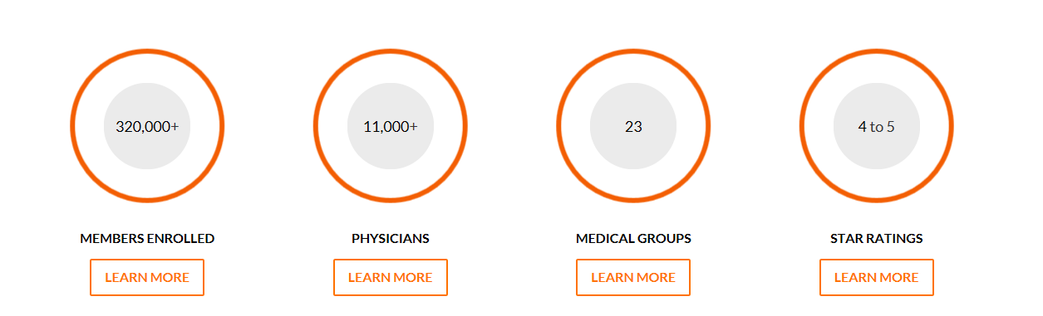

4 to 5

24

435,000+

11,000+

**LEADERSHIP TRAITS**

PMH has a core set of values and behaviors which apply to all employees, including leaders. The PMH Leadership Traits are specific characteristics of successful leaders within Prospect.

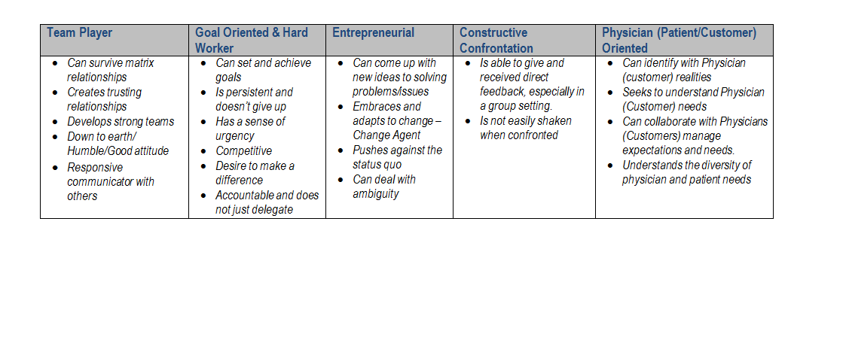

Chief Medical Officer

Prospect Medical System

Home Base and Scope:

Orange, California / California

The Chief Medical Officer provides leadership, direction, and planning for a wide variety of medical and related activities for Prospect Medical Systems (PMS). This executive serves as the liaison and resource on matters pertaining to clinical activities and directly oversees the Medical Management Department at PMS. The CMO is committed to the mission of quality, safety, service, and improvement of patient clinical outcomes and cost effectiveness. Additionally, he or she is the leader in promoting physician performance in these areas.

The Chief Medical Officer will report to the Chief Executive Officer of Prospect Medical System.

Responsibilities:

* Develops, reviews, updates, seeks consultation, and implements medical policies and processes that promote and ensure delivery of appropriate clinical care.
* Ensures effective and aggressive utilization management and case management.
* Leads the clinical and operations staff to provide oversight of the care provided to patients. Directly supervise medical directors and others as appropriate.
* Intervene with individual physicians or clinical staff when there are performance or behavioral issues.
* Partner with the organization based quality and case managers and other clinical staff to respond to and investigate adverse events; then develop and implement appropriate action plans.
* Partner with the CEO to address physician concerns and develop key physician contracts in collaboration with the CEO, finance, and contracting department.
* Collaborate with leadership to standardize programs and clinical care where appropriate across the enterprise.
* Participate in strategic planning for the network and identify appropriate system level goals and targets.
* Develop state of the art cost containment systems and processes to promote the efficient use of clinical resources.
* Additional responsibilities may be assigned by the CEO based on needs of the organization. This may include serving as an executive sponsor and mentor for a service line, leading a quality initiative, participating in specialty task forces and other duties as assigned. Special projects or unique local responsibilities may also be added at the discretion of Prospect Medical’s President and CEO based on local needs.

Qualifications:

* Strong managed care background. California experience required.
* Knowledge of federal, state, and private health care policies and regulations.
* Experience with incentive or claim based programs to drive utilization management and quality of care.

Requirements:

* MD or DO licensed in the state of California.
* Minimum of five years’ medical director, or equivalent executive/administrative experience within a health plan, IPA, or medical group environment.
* Minimum of three years of direct clinical or acute care experience.
* Demonstrated leadership capabilities.
* Board certified physician.
* Experience working with operational areas within a health plan or IPA.
* Certification or advanced training in operations improvement preferred.
* Leadership experience in a Medical Group or IPA environment strongly preferred.